# 7th Testing – 17th May

Story 16: Manually Add Meta Data when Uploading files

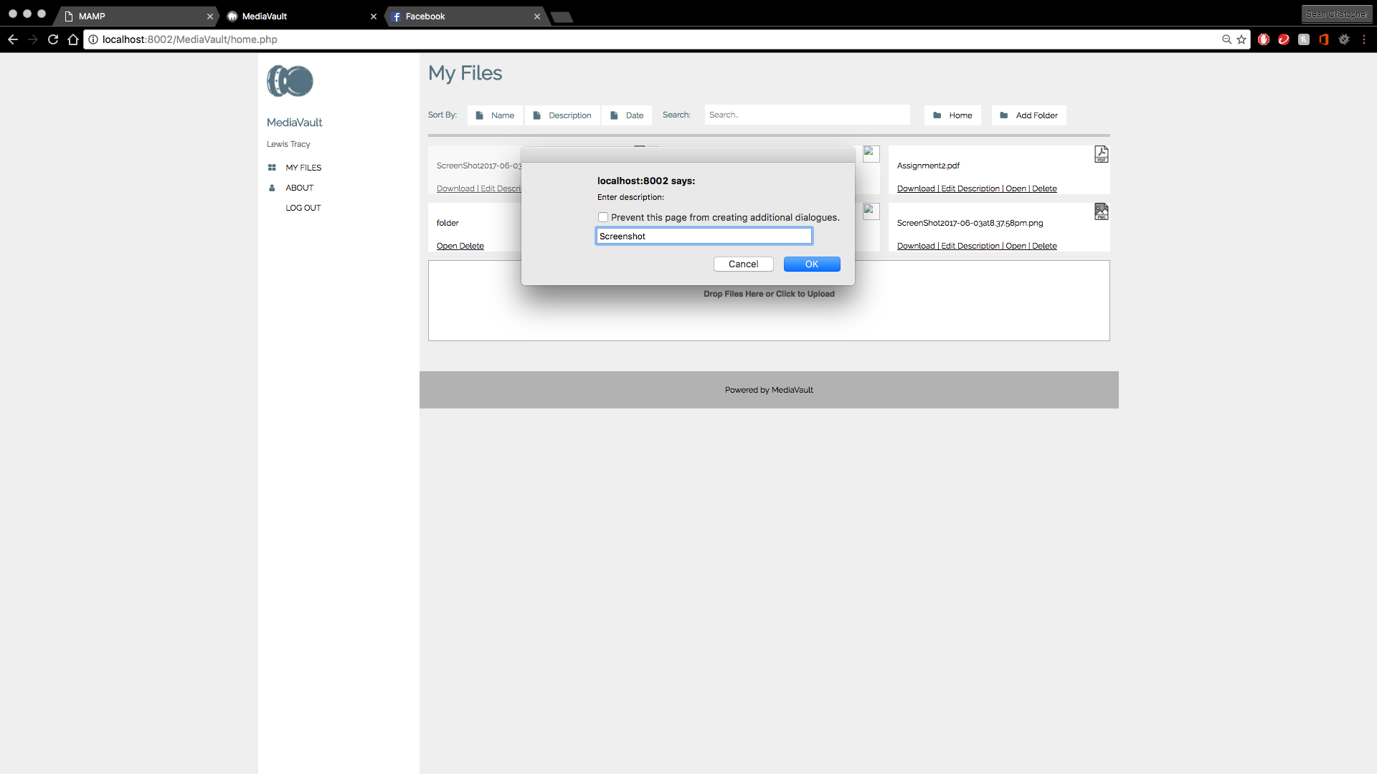

* Button “Edit Description” functions and adds a pop up message to edit file’s description

Story 13: Search a File

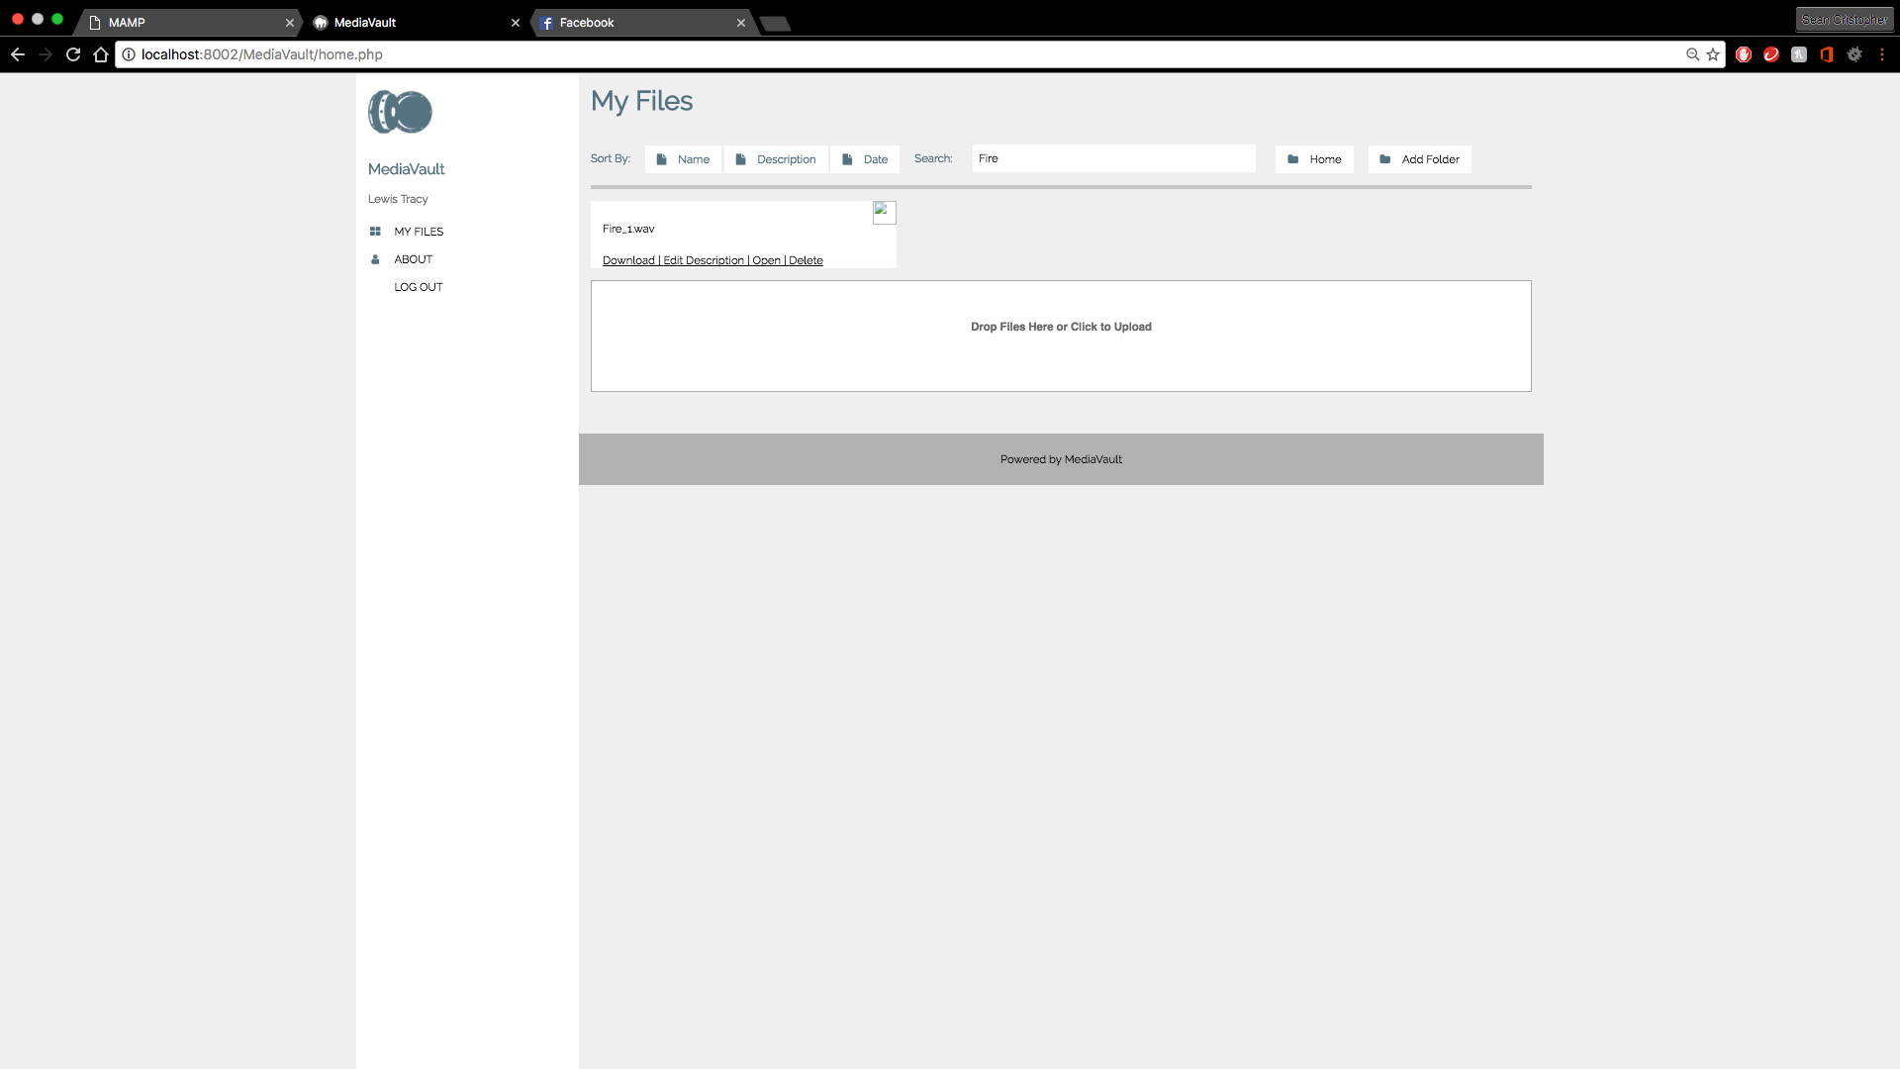

* Search box is added
* Test shows that search is functioning
* Retrieves the searched file from SQL search results

Story 16B: Automatically Add Meta Data when Uploading files

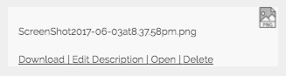

* Tests shows uploading a file/folder automatically adds meta data

Summary: Testing process successful. User stories are completed and functioning